System Architecture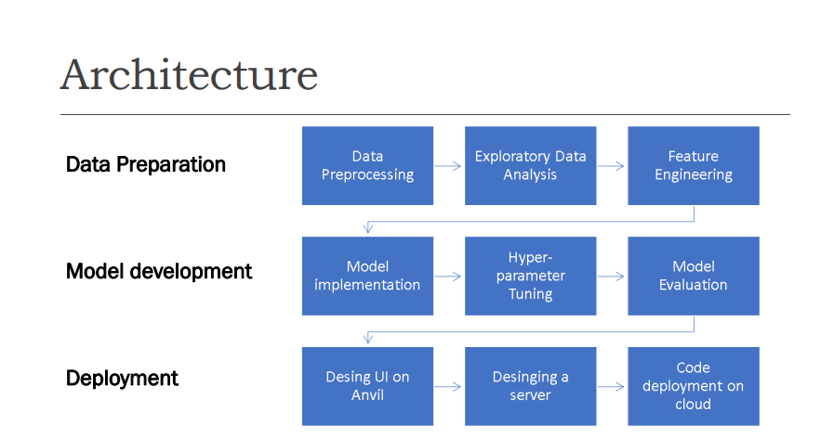

Components
- Data Ingestion:
  - Source: Kaggle dataset
  - Preprocessing: Cleaning, encoding, scaling
- Model Training:
  - Algorithm: XGBoost
  - Training and tuning
- Web Application:
  - Framework: Flask (or Django)
  - Frontend: HTML, CSS, JavaScript
- Prediction Service:
  - Endpoint: /predict
  - Input: 23 feature values
  - Output: Prediction result

Data Flow
- User Input:
  - User inputs data through the web interface.
  - Data is sent to the backend server.
- Backend Processing:
  - The server processes the data and feeds it into the trained model.
  - The model returns the prediction result.
- Output Display:
  - The result is displayed to the user.

Description
- User Interface:
  - The user interface collects user inputs and displays predictions.
  - Built using HTML, CSS, and JavaScript.
- Backend Server:
  - The server processes input data, interacts with the model, and returns predictions.
  - Built using Flask (Python).
- Model:
  - The XGBoost model is trained on preprocessed data to predict defaults.
  - The model is loaded by the Flask application for making predictions.

Diagram
+------------------+ +----------------------+ +-----------------+
| | | | | |
| User Interface +------->| Backend Server +------->| Model |
| | | (Flask Application) | | (XGBoost) |
| | | | | |
+------------------+ +----------------------+ +-----------------+

